Two types of services in MS Azure, none is better than the other

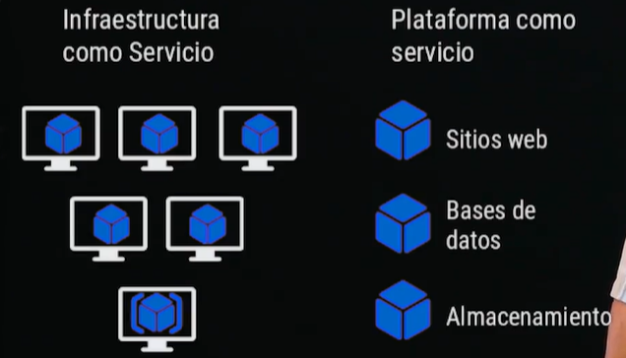

**IaaS**

----

- Infrastructure as a Service

- YOU HAVE CONTROL OVER YOUR SERVERS, SECURITY POLICIES, because you design them.

- YOU HAVE (ALSO) CONTROL OVER YOUR CODE

- As you create the architecture, if 'may' not be so optimal you you don't do a good design

- Create virtual machines (one or more)

- Windows / Linux

- VPN

- Communicate your virtual machine(s) with your machines

- hybrid cloud

- Load balance between machines

- Balance the load between virtual machines

- Create a Web Server and balance the load between machines

**PaaS**

----

- Platform as a Service4

- YOU HAVE CONTROL ONLY OVER YOUR CODE!!!

- The cloud takes care how to optimize your architecture, not you

- YOU DON'T THINK HOW TO HANDLE THE SERVERS

- Inside one of the virtual machines

- Type of Storages

- Sql / Non Sql

- MariaDb, PostgreSQL, Blob, Word Press, Hiperscale (huge amount of transactions)

- Non Sql : Firestore

- Queues

- Web and Logic App

- Present data

- Create automatic processes <- (RPA)

If we decide to use IaaS there are 2 options

* Use cluster of virtual machines with load balance for user requests
* Use container, Kubernetes

Un Balanceador de carga

Dispositivo de hardware o software que se pone al frente de un conjunto de servidores que atienden una aplicación y, asigna o balancea las solicitudes que llegan de los clientes a los servidores usando algún algoritmo.

Construiremos una aplicacion

- 2 maquinas virtuales con Ubuntu

- 1 balanceador de carga, que evaluara cual maquina debe enviar los requerimientos de los usuarios.

Un balanceador de carga recibe las peticiones y la distribuye a un servidor o más en base a un algoritmo como:

• Round robin

• Weighted round robin

• Least connections

• Least response time

Los balanceadores de tipo capa 7 pueden distribuir las peticiones en datos de aplicación como cookies, headers HTPP, datos del mensaje, etc.